

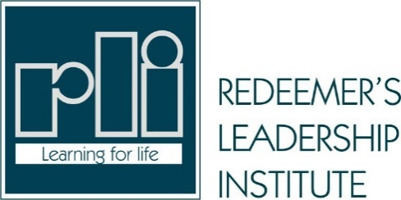

Certificate of Completion

This certificate is awarded to

CONSTANCE CHIWEOKE AMADI

Having satisfactorily completed the course

BRIDGEGAP

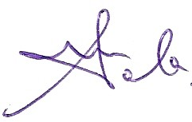
Chairman RLI

Operations Director RLI
01/15/2022

01/15/2022

