
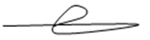
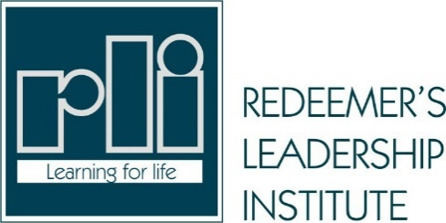

Certificate of Completion

This certificate is awarded to

OLUWOLE FELIX AJAYI

Having satisfactorily completed the course

BRIDGEGAP

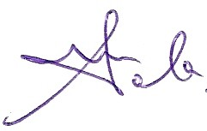
Chairman RLI

Operations Director RLI
01/15/2022

01/15/2022

